Predicting Litigated Contract Clauses
Ye Sun, Julian Nyarko

1. Overview
We study whether an AI agent can identify the contract clauses that end up being disputed in court. Instead of relying on expert annotations, we label a clause as risky if the parties litigated over it in a federal case and the court construed it in its opinion. All other clauses in the contracts filed in the same cases serve as negatives. A clause that the court upheld counts the same as one construed against its drafter, because the dispute itself is the cost.

2. Dataset Construction
We started from federal court opinions filed under 12 Westlaw Key Numbers related to contract interpretation, and built the dataset in five steps:
- Collect. Link each opinion to its docket, download the attached contracts, and convert them to text with OCR. Duplicates and unreadable scans are removed.
- Split into clauses. A model (GPT-5.6) splits each contract into clauses without seeing the court opinion, so clause boundaries do not depend on what the court said.
- Find the disputed clauses. The model reads the opinion with the contracts of the case, identifies the disputed clauses, and lists each issue the court discussed with a quote from the opinion.
- Filter. Issues that can only be understood from material outside the filed documents, such as emails between the parties, are removed.
- Assign a risk type. Each issue gets a type from the case's Westlaw Key Numbers: Type 1 (intrinsic) for problems within the clause itself, such as an ambiguous term, and Type 2 (relational) for problems in how the clause fits with the rest of the contract.
The model only points to the location of each clause; the text is cut directly from the source file, so every clause is verbatim. The final dataset is summarized below.
Cases | Contracts | Clauses | Litigated clauses | Issues (Type 1 / Type 2)
53 | 87 | 10,102 | 170 (1.7%) | 225 (149 / 76)

3. Agent Experiment
For each contract, a Claude Opus 5 agent read the contract, the other filings of the case, and three worked examples, but not the court opinion. For every clause, it listed the issues a court might construe, each with a description, a risk type, and a probability. We evaluated it on 84 contracts (9,890 clauses, 163 litigated) with two tests:
- Finding the clause. Does the agent rank litigated clauses above the rest? We compare against ranking by clause length alone.
- Naming the issue. A separate model (GPT-5.6) checks whether each agent issue matches an issue the court discussed; as a control, it repeats the check against another clause of the same case.
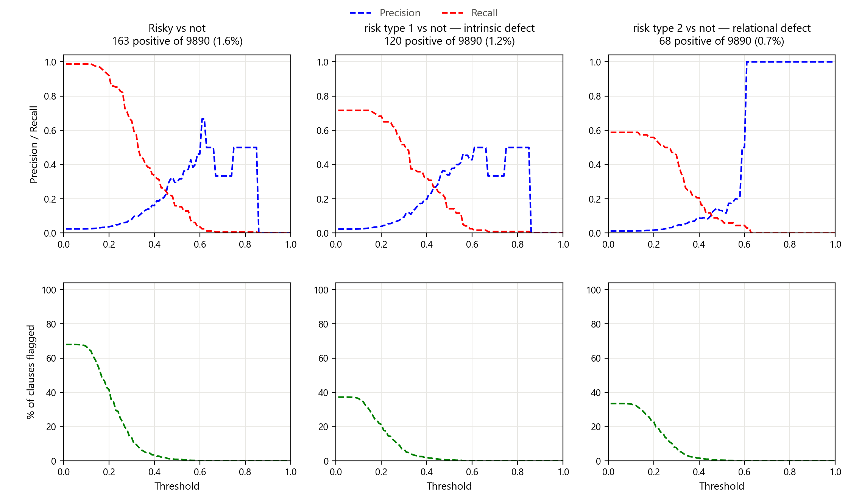
Figure 1. Finding the litigated clause
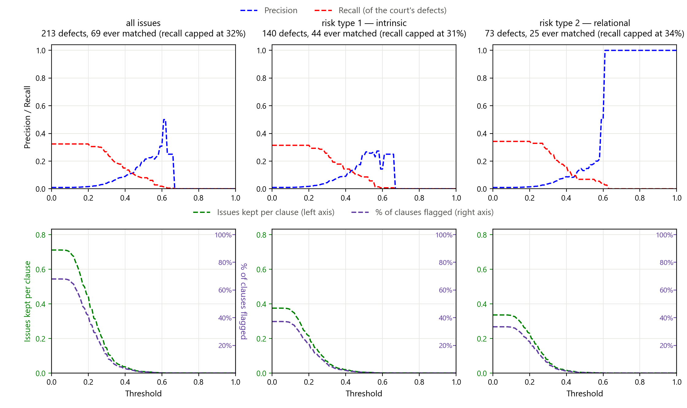
Figure 2. Finding the litigated clause and naming the court's issue
In each figure, the top row shows precision and recall as the probability threshold increases, and the bottom row shows the share of clauses flagged at that threshold. In Figure 1, the agent ranks litigated clauses well, with an ROC-AUC of 0.868 against 0.691 for clause length alone; on Type 2 it is no better than length (0.690). If the threshold is set so that about 20% of clauses are flagged (t = 0.27), the agent catches 119 of the 163 litigated clauses (73%), although precision is only 6% because litigated clauses are 1.6% of all clauses.
Figure 2 also requires the agent to name the issue the court discussed. At the same 20% flag rate, the agent names 64 of the 213 court-discussed issues (30%). This is close to the 69 issues it names at any threshold, so most of the loss comes from naming a different issue, not from the threshold. Overall, about one third of the agent's issues on litigated clauses (33.0%) match the court, against 14.2% in the control. The agent is good at finding where to look, but weaker at saying what is wrong.

4. Feedback from Manual Review
A law-trained colleague manually reviewed several cases against the opinions. The main observations were:
- Review time varies widely. A simple case (one vague phrase in a noncompete) took about 10 minutes; a complex financial case took about 3 hours and was still hard to call.
- Drafting versus transaction risk. The agent may be finding the clauses commonly litigated in a type of deal, rather than poorly worded ones.
- Scope of the claim. The data show which clause is disputed once a contract is in litigation, not how likely a clause is to cause litigation.
- Relational risk. When two clauses conflict, it is unclear which clause the risk belongs to.
- Courts as ground truth. Courts often rule on one narrow clause or on procedural grounds, so labels reflect what the court chose to address.

5. Discussion and Next Steps
We believe current LLMs are already strong verifiers: when a human and the LLM disagree on a match, it is usually a judgment call, or the LLM is right. Our validation comes from the parties who litigated, and the LLM only matches the agent's issues to the court's.
The open question is the quality of the issues that do not match, since an unmatched issue, or a clause that was never litigated, may still carry real risk. We would like practising attorneys to review the unmatched issues (140 of 209 on litigated clauses, plus a sample on other clauses) and judge whether each is a real contract risk. This would measure the quality of both matched and unmatched issues.

